附件2
论文中英文摘要
作者姓名：左建平
论文题目：温度-应力共同作用下砂岩破坏的细观机制与强度特征
作者简介：左建平，男，1978年3月出生，2001年9月师从于中国矿业大学(北京) 谢和平院士，于2006年6月获博士学位。

中 文 摘 要
针对矿产资源深部开采以及核废料处置等重大工程实际需求，开展在温度-应力共同作用下岩石变形与强度的理论与实验研究具有十分重要的意义。针对目前国际上有关温度-应力共同作用下岩石的破坏研究大多局限于宏观尺度上的研究，以及不能实时在线观察岩石热开裂实验中缺陷变化规律，本文从实验方法和手段上进行了改进，强调岩石细观结构演化对宏观力学行为的影响。借助SEM高温疲劳实验系统实时在线地观察和研究了温度-应力共同作用下砂岩细观尺度上的变形破坏过程，通过不同温度条件下的全程应力-应变曲线分析，获得了砂岩破坏时温度和应力的临界条件，发现温度从25℃升到150℃，抗拉强度有所提高；而温度由150℃升高到300℃，抗拉强度又有所下降，即表现出温度对抗拉强度影响的非线性分段特性，这是以往研究中没有观察到的现象。为此，本文分别从不同温度下细观尺度上砂岩的热开裂、变形破坏机制及断口形貌进行了系统研究，进一步揭示了这种现象的细观物理力学机制。并且发现褶皱不仅仅是挤压作用造成的，在拉应力和温度长时间的共同影响下也可能形成褶皱；随着温度的升高，砂岩表面热开裂的裂纹分布模式具有分形性质，其分形维数呈现非线性变化，服从经典的Boltzmann统计分布。基于这些研究，本文提出了不同温度影响下砂岩的分段强度理论模型，并进行了分析预测和实验验证，结果表明理论模型的分析预测与实验结果比较吻合。研究取得如下新的认识和结果：
(1) 实时在线观察和研究了不同温度下砂岩的热开裂，得到了砂岩热开裂的临界温度及不同温度下砂岩表面热开裂裂纹的分布规律，并对砂岩热开裂进行了分类，通过相应的细观模型对砂岩热开裂机制进行了解释，指出热膨胀不匹配和热膨胀各向异性是砂岩热开裂的主要机制。而热开裂的演化影响着砂岩强度的变化。100℃以下砂岩表面不发生热开裂；更高温度时，随着温度的变化，砂岩表面热开裂的裂纹分布模式具有分形性质，当温度低于150℃时，砂岩表面分形维数变化不明显；当温度大于150℃之后，随着温度的升高，砂岩表面分形维数呈现非线性变化过程，服从经典的Boltzmann统计分布，并赋予分形维数一定的物理含义：表示不同温度条件下砂岩表面热开裂的裂纹演化规律。实验表明150℃左右为砂岩热开裂萌生和形核的临界温度。根据热开裂的路径，在细观层次上把砂岩表面的热开裂分矿物颗粒上的热开裂、粘土胶结物与矿物颗粒的界面的热开裂、矿物颗粒与矿物颗粒之间的热开裂、粘土胶结物上的热开裂；而在微观层次上把矿物颗粒上的热开裂再细分为沿晶热开裂、穿晶热开裂及两者的混合热开裂。本文通过相应的细观模型，如球形内含物模型、两颗粒力学模型、矿物颗粒或晶粒热变形模型等对部分热开裂现象进行了定性的解释，并对热开裂的影响因素进行了分析。
备注：相关研究成果已发表于2007年《地球物理学报》第50卷第4期及2005年《Physica E》第28卷第1期上；一篇投给《Journal of Geophysical Research-Solid Earth》（影响因子2.95）已被接收。

(2) 实时在线研究了温度-应力共同作用下砂岩的细观破坏过程，得出了150℃左右是细观砂岩承载能力变化的临界温度；随着温度的升高，砂岩的断裂机制由脆性机制向延性机制转变，抵抗和协调变形的能力也会得到增强；并对砂岩细观破坏机制有了新的认识。发现砂岩的脆性断裂可在两个甚至多个地方发生、不同矿物可能是独立承载、温度-应力共同作用下砂岩的脆性断裂过程的裂纹分叉等新现象。通过不同温度条件下载荷-位移曲线分析，指出细观砂岩承载能力变化的临界温度为150℃左右：温度从25℃升到150℃时，承载能力有所升高；而温度150℃升到更高温度(200℃、250℃和300℃)，承载能力又有所下降；通过比较不同温度影响下砂岩宏观断裂位置分布图和主裂纹附近的微裂纹，发现随着温度的升高，砂岩的细观断裂机制有由脆性机制向延性机制转变的趋势，抵抗和协调变形的能力也会得到增强，而这是影响承载能力变化的表现。利用数字散斑相关方法对扫描电镜下细观变形场的测量，得到了砂岩试件破坏时的变形场，发现砂岩的局部区域出现了转动及不均匀变形。
备注：相关研究成果已发表在2008年《力学学报》第40卷第6期及即将2009发表在国际杂志美国ASTM协会的《Journal of Testing and Evaluation》第37卷第1期上。

(3) 得到了地球物理学中形成褶皱的一种新机制，认为褶皱现象不仅仅是挤压作用造成的，也可能是受到拉应力和温度长时间的共同影响而造成的；通过对温度-应力共同作用下砂岩断口形貌的系统研究，系统分析和揭示了温度对砂岩微观断裂机制及抗拉强度的影响，建立了温度-应力共同作用岩石整体破坏准则。通过不同温度下砂岩的局部解理断口及局部疲劳断口的实验对比，以及不同温度下原子在平衡位置附近振动模型的理论分析，证实了温度对砂岩的微观断裂机制的影响，即随着温度的升高，砂岩的断裂机制由以局部脆性断裂机制为主向局部脆性和延性耦合断裂机制转变，其中150～300℃是脆延过渡区的转变温度，在这个过渡区，岩石的断口形貌更为多样和复杂。而断口微观形貌的变化及脆性机制向延性机制的转变是岩石强度变化的表现。根据砂岩的断裂路径，在细观层次上把砂岩的断裂分为沿颗粒断裂、穿颗粒断裂、胶结物断裂及沿颗粒和穿颗粒耦合断裂；在微观层次上，把穿颗粒断裂分为沿晶断裂、穿晶断裂和两者耦合断裂。通过大量的断口SEM图分析和阐述了不同温度下的岩石断裂的微细观机制，如疲劳断裂、解理断裂、准解理断裂和沿晶断裂等，并通过相应的断裂机制示意图进行了解释；而疲劳裂纹可能是一种微细观尺度上的“褶皱”，因此作者推测在地球物理中，褶皱现象不仅仅是挤压作用造成的，也可能是受到拉伸载荷和温度长时间的共同影响而造成的。根据实验现象，建立了温度-应力共同作用下岩石整体破坏准则：
$$D_{a}(D_{m}∪D_{n}∪D_{k})≤D_{\text{ac}}(D_{m}∪D_{n}∪D_{k})$$
$$D_{b}({\overset{—}{D}}_{m}∪{\overset{－}{D}}_{n}∪{\overset{－}{D}}_{k})≤D_{\text{bc}}({\overset{—}{D}}_{m}∪{\overset{－}{D}}_{n}∪{\overset{－}{D}}_{k})$$
认为只有当所有出现损伤的子结构及决定性损伤子结构都达到其相应的临界值时，岩石才会最终破坏，该准则包含了部分的细观破坏机制及岩石真实的破坏过程。
备注：上述研究成果将发表于2007年《中国科学E:技术科学》第37卷第11期，2007年《岩石力学与工程学报》第26卷第12期及2007年《Science in China Series E: Technological Sciences》第50卷第6期上；一篇投稿给《Mechanics of Materials》。

(4) 本文通过系统的实验和研究获得了不同温度对砂岩抗拉强度的影响规律：从25℃升到150℃，抗拉强度有所升高；从150℃升高到300℃，抗拉强度又有所下降。基于已有的研究成果和本文的实验结果，提出了不同温度影响下砂岩的分段强度理论模型，并进行了分析预测，结果表明理论模型的分析预测与实验结果比较吻合。从热力学的角度说明了岩石的破坏过程中能量耗散是必然的结果，得出了岩石体积单元的能量守恒定律和破坏不可逆过程的微分表达式，为阐述岩石破坏过程中的能量耗散规律提供了依据。基于一些经典研究，得到了温度-应力共同作用下损伤岩石的本构方程，该式与热弹性体Duhamel-Neumann公式具有相同的形式，但该模型考虑了真实岩石内部会由于载荷引起的损伤和温度引起的热损伤两个因素。基于可释放能量的岩体整体破坏准则，得出了温度-应力共同作用下的基于能量耗散和能量释放的岩体整体破坏准则，该准则在原来的整体破坏准则基础上推广到适合各个主应力方向，这由可释放的应变能分配系数和沿各个主应力方向的临界破裂应力来确定。基于这些理论及本文的实验结果，本文提出了不同温度影响下砂岩的分段强度理论模型：
$$σ=\left\{\begin{matrix}σ_{0}+{\text{Ae}}^{T/{T_{0}}} & \text{25}°C≤T≤\text{150}°C \\ σ_{\text{min}}+\frac{σ_{\text{max}}−σ_{\text{min}}}{1+e^{(T−T_{0})/{\text{dx}}}} & \text{150}°C≤T≤\text{300}°C\end{matrix}\right.$$
并进行了分析预测，结果表明理论模型的分析预测与实验结果比较吻合，如图1。
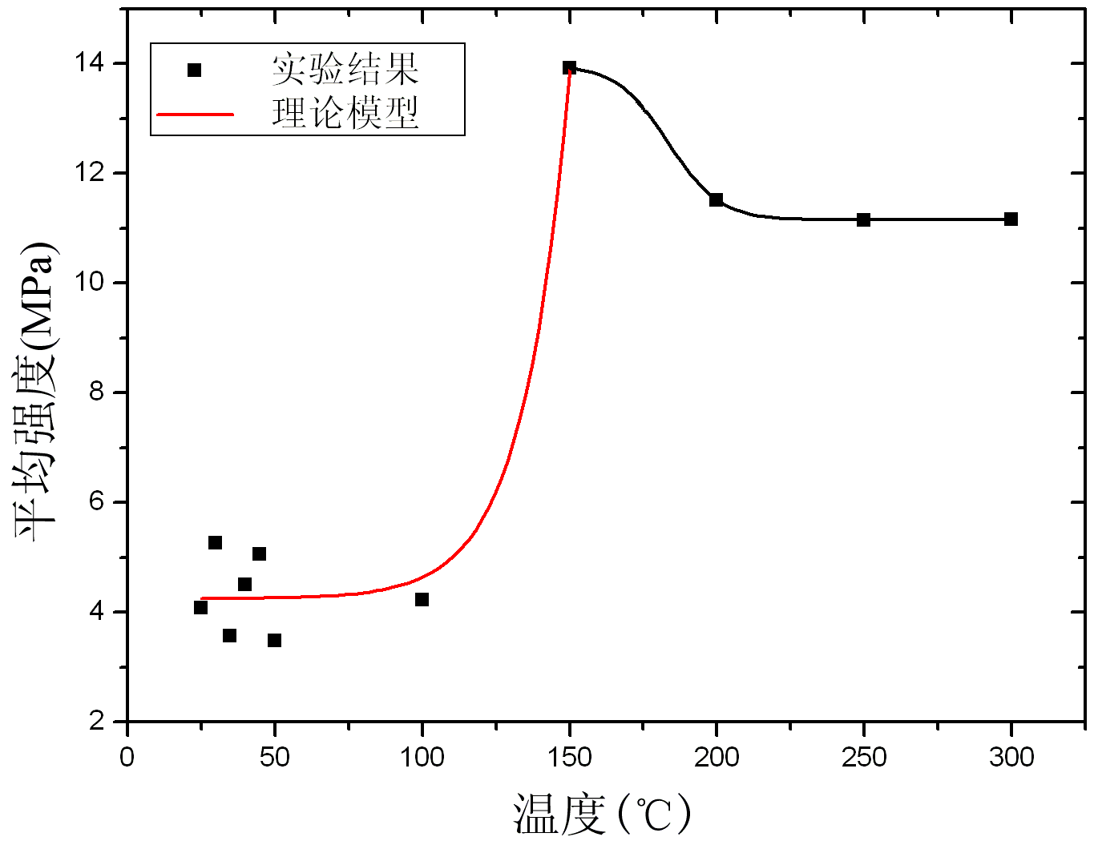
图1 分段强度理论模型与实验对比
备注：相关研究成果发表于2005年《岩石力学与工程学报》第24卷第16期，2008年国际期刊《International Journal of Rock Mechanics and Mining Sciences》第45卷第4期，2008年《岩土力学》第29卷第6期，和 2008年《工程力学》第25卷第5期上。

关键词： 温度-应力共同作用，SEM，热开裂，细观尺度，断口形貌，实验研究，拉伸强度

Sandstone failure mechanism at the meso-scale and its strength characteristics under the thermal-mechanical action
Zuo Jianping

ABSTRACT
It becomes more and more important to study and understand the deformation and strength properties of rocks to meet the increasing demands of deep mining and nuclear waste disposal. The current researches focus on macroscale rock failure under thermal-mechanical coupling. And rock thermal cracking experimental research can’t be observed real-time. So the objectives of the dissertation are to study the rock failure and thermal cracking through improving on experimental method and instrument. And it emphasizes that the evolution of rock meso structure is a key factor and will affect macro mechanical behaviour of rock. The high temperature fatigue testing system with scanning electron microscope (SEM) was employed to study the real-time deformation and failure process of sandstone at meso-scale under the condition of thermal-mechanical coupling effects. The dissertation describes and analyses meso structure that the cracks distribution of sandstone surface thermal cracking under different temperatures exhibits fractal behaviour. Experimental results indicates that the tensile strength increases as the temperature increases from 25ºC to 150 ºC, and decreases as the temperature increases from 150 ºC to 300 ºC. The similar phenomenon has not been reported in the previous literature. Also it is different with the relationship of compression strength varying with temperature. Therefore the dissertation studies systematically thermal cracking, deformation, meso failure mechanism and fractography of sandstone under different temperatures. And the meso physical mechanisms are discovered. These experimental results have shown the evidence of the thermal effects of rock failure. Based on these studies and experimental results, a segmented strength theoretical model on thermal-mechanical coupling is proposed. The results of theoretical prediction are in agreement with the laboratory experiments approximately. Great progresses have been made in the dissertation as following:
(1) SEM in-situ observations for thermal cracking of sandstone under different temperatures are achieved. The dissertation obtains crack distribution regularity and critical temperature of thermal cracking. Also thermal cracking modes are classified according to thermal cracking path. The thermal expansion mismatch and thermal expansion anisotropic are the main mechanism of thermal cracking of sandstone. And thermal cracking affects sandstone strength. The cracks distribution of sandstone surface thermal cracking under different temperatures has fractal effects. When the temperature is less than 150 ºC, the fractal dimension of sandstone thermal cracking surface changes hardly. But when the temperature rises from 150 ºC to 300 ºC, the fractal dimension will present a nonlinear variation, and is a classical Boltzmann statistical distribution. Also the fractal dimension here has clearly physical meaning representing thermal cracking evolution on sandstone surface under different temperatures. Experimental result shows that the initiation and nucleation critical temperature of sandstone thermal cracking is about 150 ºC. According to thermal cracking path, the thermal cracking of sandstone surface on the meso-scale can be divided into mineral particle thermal cracking, interface thermal cracking between clay cement and mineral particles, thermal cracking between mineral particles, clay cement thermal cracking. And mineral particles thermal cracking can be divided into intercrystalline thermal cracking, transgranular thermal cracking and mixed thermal cracking of the both on micro scale again. Some thermal cracking phenomena are interpreted by means of the corresponding meso-scale model, such as spherical inclusion model, two body mechanical model and mineral particles or crystalline particle thermal deformation model and so on.
(2) The meso failure progress of sandstone under thermal-mechanical coupling effects was observed and studied in situ. The experimental result indicates that 150 ºC is critical temperature of carrying capacity of sandstone and meso fracture mechanism will transfer from brittle fracture mechanism to ductility fracture mechanism when temperature increases. The dissertation presents new understandings about fracture mechanism of meso-scale sandstone, such as brittle fracture of sandstone could occur in two places or more, the minerals can bear independently, brittle fracture of sandstone under thermal-mechanical coupling effects can bifurcate also etc. Experimental results show that the threshold temperature of load-carrying capability of meso-scale sandstone is about 150 ºC. Through comparing and analysing sandstone fracture position under different temperatures and branching cracks which distribute near the main crack, it shows that meso fracture mechanism transfer from brittle fracture mechanism to ductility fracture mechanism when temperature increases from 25 ºC to 300 ºC. Also the capacity of resist and compatible deformation will enhance. It also shows that the damage of meso-scale sandstone isaffected by various fracture patterns. Digital speckle correlation method (DSCM) was used to calculate micro-deformation field of SEM images of sandstone. It is found that DSCM can measure continuously of the local failure process of rock perfectly. Also some new phenomena such as rotation deformation and non-uniform deformation are found in local area of sandstone surface.
(3) Through analyzing systematically sandstone fractography under the condition of coupled thermal-mechanical behaviour, the dissertation disclosure the temperature effects on sandstone micro fracture mechanism and tensile strength of sandstone. Also a whole failure criterion under thermal-mechanical coupling effects is proposed. Many SEM images of sandstone fractography under coupling effects of thermal-mechanical process are studied systematically. Through comparing the difference of local cleavage fracture and fatigue fracture under different temperature, and analysing theoretically the atom vibration model in the vicinity of the equilibrium position in different temperature, it is confirmed that temperature certainly influences the micro-fracture mechanism of sandstone. That is fracture mechanism of sandstone under coupled thermal-mechanical effects will transfer from local brittle fracture mechanism to coupling fracture mechanism of local brittle and ductility when temperature increases. The temperature zone from 150 ºC to 300 ºC is the brittle-ductility transition region. And in the transition region, the fracture modes of rock are more complicated and multiplicity. According to fracture paths of sandstone, the fracture modes of sandstone in meso-scale are divided into trans-grain fracture, cry-grain fracture, clay cement fracture and coupling fracture of trans-grain fracture and inter-grain fracture. In micro-scale, trans-grain fracture are divided into transcrystalline, intercrystalline and mix fracture of trans-grain and inter-grain. At the same time, the dissertation studies rock micro/meso fracture mechanism in the different temperature after analysing a great deal of fractography SEM images, such as the fatigue fracture, cleavage fracture, quasi-cleavages fracture and transcrystalline fracture etc. And some fracture mechanism sketch maps are proposed to demonstrate some fractographys respectively. The fatigue crack is fold at meso-scale. Then the author speculates that the tensile stress and temperature coupling effect is another mechanism to form the fold in physical geography besides mouthpiece pressing. In the light of the experimental phenomena, a whole failure criterion under coupled thermal-mechanical process is proposed in the dissertation:
$$D_{a}(D_{m}∪D_{n}∪D_{k})≤D_{\text{ac}}(D_{m}∪D_{n}∪D_{k})$$
$$D_{b}({\overset{—}{D}}_{m}∪{\overset{－}{D}}_{n}∪{\overset{－}{D}}_{k})≤D_{\text{bc}}({\overset{—}{D}}_{m}∪{\overset{－}{D}}_{n}∪{\overset{－}{D}}_{k})$$
The criterion has definite physical meaning which rock will failure finally when all damaged substructure and critical damage substructure achieve the threshold value. Also the criterion contains some meso-failure mechanism and reality rock failure process.
(4) A new influencing regularity of sandstone tensile strength vs temperature is proposed after analyzing experimental results systematically: the tensile strength will increase with the temperature increment from 25 ºC to 150 ºC, and will decrease with the temperature increment from 150 ºC to 300 ºC. Based on present theories and experimental results, the dissertation proposes a segmented strength theoretical model under the condition of coupled thermal-mechanical effects. The analysed and forecast results coincide with experimental results. At last in the dissertation, some theoretical researches are done to study coupled thermal-mechanical effects. In the coupled thermal-mechanical process, the rock failure in essence is the process of energy dissipation and energy release. The energy conservation law and the failure irreversibility process of rock representative volume element are expressed by the differentiated equation in the dissertation. They explain the thermodynamics evidence of the energy dissipation in the rock failure process. Based on some classical researches, the rock damage constitutive equation under coupled thermal-mechanical process is achieved. Though this equation has the same format with the Duhamel-Neumann equation of thermal elastic body, it includes the damage caused by external load and thermal damage caused by high temperature. Based on whole failure criterion of energy dissipation and energy release principle, a whole failure criterion under the condition of coupled thermal-mechanical process is achieved. The new criterion not only includes temperature factor, but promotes the initial whole failure criterion to suit for different main stress direction which is determined by the distribution coefficient of release strain energy and critical failure strength. Based on the present theoretical research and experimental results, purposes that the fragment strength theory model demonstrates the experiment, and predictable result is appropriate to the experiment value. A segmented strength theoretical model under the condition of coupled thermal-mechanical process is proposed:
$$σ=\left\{\begin{matrix}σ_{0}+{\text{Ae}}^{T/{T_{0}}} & \text{25}°C≤T≤\text{150}°C \\ σ_{\text{min}}+\frac{σ_{\text{max}}−σ_{\text{min}}}{1+e^{(T−T_{0})/{\text{dx}}}} & \text{150}°C≤T≤\text{300}°C\end{matrix}\right.$$
The analysed and forecast results coincide with experimental results approximately as Fig. 1.
Fig.1 Theoretical prediction vs experiment data

Key words: Thermal-mechanical action, SEM, Thermal cracking, Meso-scale, Fractography, Experimental research, Tensile strength

